**Ex:No:1 WRITE A PROGRAM TO READ THE TEMPERATURE IN CELSIUS AND CONVERT INTO FAHRENHEIT**

**AIM:**

To read the temperature Celsius and convert into Fahrenheit.

**ALGORITHM**:

Step1: Start the program

Step2: Create the class tempcoversion

Step3: give the instant variable float

Step4: Get the DataInputStream and give the conversion Celsius into Fahrenheit F=(C*9/5)+32.

Step5:Execute and terminate the program.

**PROGRAM**:

import java.io.*;

class tempconversion

{

public static void main(String arg[])

{

float F=0f;

float C=0f;

try

{

DataInputStream din;

din=new DataInputStream(System.in);

System.out.println("Enter the value of celsious");

C=Float.parseFloat(din.readLine());

F=(C*9/5)+32;

System.out.println(C+"celsious="+F);

}

catch(IOException e)

{

System.out.println(e);

}

}

}

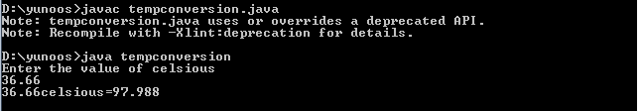

**Result** :Thus the above java program was executed and verified successfully.

**EX:NO:2 WRITE A PROGRAM TO READ 2 INTEGERS AND FIND THE LARGEST NUMBER USING CONDITIONAL OPERATOR**

**AIM:**

To read to integers and the largest number using conditional operator.

**ALGORITHM**:

Step1: Start the program

Step2: Create the class largest

Step3: Give the instant variable float

Step4: Get the DataInputStream and get the largest number for the given expression.

Step5:Execute and terminate the program.

**PROGRAM**:

import java.io.*;

class largest

{

public static void main(String args[])

{

int n1=0;

int n2=0;

try

{

DataInputStream din;

din=new DataInputStream(System.in);

System.out.println("Enter the value of the number");

n1=Integer.parseInt(din.readLine());

System.out.println("Enter the value of the second number");

n2=Integer.parseInt(din.readLine());

int large=n1>n2?n1:n2;

System.out.println("The largest number is "+large);

}

catch(IOException e)

{

System.out.println(e);

}

}

}

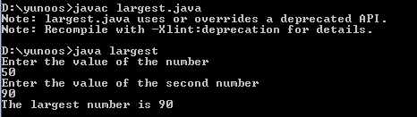

**Result** :Thus the above java program was executed and verified successfully.

**EX:NO:3 WRITE A PROGRAM TO READ AN INTEGER AND FIND THE FACTORIAL OF A NUMBER**

**AIM:**

To read an integer and find the factorial of a number.

**ALGORITHM**:

Step1: Start the program

Step2: Create the class factorial

Step3: Give the instant variable float

Step4: Get the DataInputStream and get the factorial calculations.

Step5: Execute and terminate the program.

**PROGRAM**:

**import java.io.*;**

**class factorial**

**{**

**public static void main(String arg[])**

**{**

**DataInputStream din;**

**din=new DataInputStream(System.in);**

**int n;**

**try**

**{**

**System.out.println("Enter a positive number");**

**n=Integer.parseInt(din.readLine());**

**int f=1;**

**for(int i=1;i<=n;i++)**

**f*=i;**

**System.out.println(+n+"!="+f);**

**}**

**catch(IOException e)**

**{**

**System.out.println(e);**

**}**

**}**

**}**

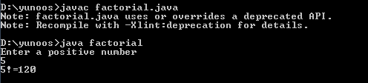

**Result** :Thus the above java program was executed and verified successfully.

Ex :No:4 **WRITE A PROGRAM TO IMPLEMENT VECTOR CLASS AND ITS METHODS**

**AIM:**

To implement vector class and its menthods.

**ALGORITHM**:

Step1: Start the program

Step2: Create the class demovector

Step3: Give the instant variable declaration

Step4: Get the vector methods and get the vector creation.

Step5: Execute and terminate the program.

**PROGRAM**:

import java.io.*;

import java.util.*;

class demovector

{

public static void main(String args[])

{

Vector vec=new Vector(5,2);

System.out.println("Size="+vec.size());

System.out.println("Capacity="+vec.capacity());

for(int i=1;i<6;i++)

vec.addElement(new Integer(i));

System.out.println("The created vector is:"+vec);

System.out.println("Capacity="+vec.capacity());

System.out.println("Size="+vec.size());

vec.addElement(new Integer(13));

System.out.println("The created vector is:"+vec);

System.out.println("Size="+vec.size());

int n=vec.size();

Integer a[]=new Integer[n];

vec.copyInto(a);

System.out.println("The array elements are:");

for(int i=0;i<n;i++)

System.out.println(a[i]);

System.out.println(vec.removeElement(new Integer(13)));

System.out.println("The created vector is:"+vec);

System.out.println("Size="+vec.size());

String s=new String("God");

vec.insertElementAt(s,2);

System.out.println("The created vector is:"+vec);

vec.removeAllElements();

System.out.println("The created vector is:"+vec);

System.out.println("Size="+vec.size());

}

}

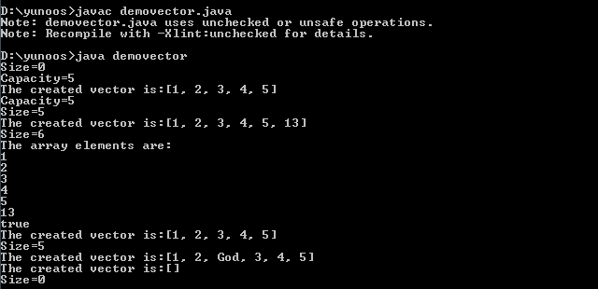

**Result** :Thus the above java program was executed and verified successfully.

EX:NO:5 WRITE A PROGRAM TO READ A STRING AND CHECK WHETHER IT IS PALINDROME OR NOT.

**AIM:**

To read a string and check whether it is palindrome or not.

**ALGORITHM**:

Step1: Start the program

Step2: Create the class palindrome

Step3: Give the instant variable declaration

Step4: Get the DataInputStream methods and get the related function.

Step5: Execute and terminate the program.

**PROGRAM**:

import java.io.*;

public class palindrome

{

public static void main(String args[])

{

String s,s1,s2="";

try

{

DataInputStream din=new DataInputStream(System.in);

System.out.println("Enter the input string:");

s=din.readLine();

int n=s.length();

s1=s.toLowerCase();

for(int i=n-1;i>=0;i--)

s2=s2+s1.charAt(i);

if(s1.equals(s2))

System.out.println("The given string "+s+"is palindrome");

else

System.out.println("The given string "+s+"is not palindrome");

}

catch(IOException e)

{

System.out.println(e);

}

}

}

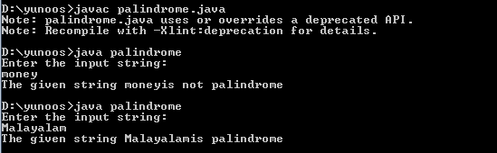

**Result** :Thus the above java program was executed and verified successfully.

Ex.No:6 Write a program to create a class with following data members

**AIM:**

To create a class with following data members.

**ALGORITHM**:

Step1: Start the program

Step2: Create the class student

Step3: Give the instant variable declaration for student.

Step4: Get the method for student and get the related function.

Step5: Execute and terminate the program.

**PROGRAM**:

class student

{

int regno;

String name;

int m1,m2,m3,total;

student(int r,String n,int n1,int n2,int n3)

{

regno=r;

name=n;

m1=n1;

m2=n2;

m3=n3;

}

void result()

{

total=m1+m2+m3;

}

void print()

{

System.out.println("Register number:"+regno);

System.out.println("Name:"+name);

System.out.println("Total mark:"+total);

}

public static void main(String args[])

{

student s[]=new student[3];

s[0]=new student(1001,"Kumar",45,90,67);

s[1]=new student(1002,"Ramu",75,90,87);

s[2]=new student(1003,"Babu",80,86,77);

s[0].result();

s[0].print();

s[1].result();

s[1].print();

s[2].result();

s[2].print();

}

}

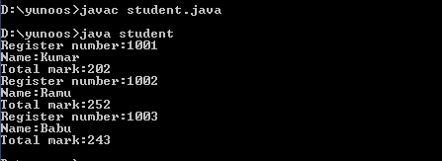

**Result** :Thus the above java program was executed and verified successfully.

**EX NO:7 Write a program that accepts radius of a circle from command line and display its area**

**AIM:**

To create a class with following data members.

**ALGORITHM**:

Step1: Start the program

Step2: Create the class student

Step3: Give the instant variable declaration for student.

Step4: Get the method for student and get the related function.

Step5: Execute and terminate the program.

**PROGRAM**:

import java.io.*;

import java.util.Scanner;

class circle

{

public static void main(String args[])

{

Scanner s=new Scanner(System.in);

System.out.println("Enter the radius");

double r=s.nextDouble();

double area=(22*r*r)/7;

System.out.println("Area of the circle is:"+area);

}

}

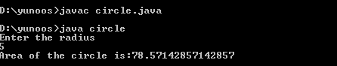

**Result** :Thus the above java program was executed and verified successfully.

Ex:No:8 Write a program to implement multilevel inheritance.

**AIM:**

To create a multilevel inheritance

**ALGORITHM**:

Step1: Start the program

Step2: Create the class vehicledemo

Step3: Give the instant variable declaration for the class vehicle.

Step4: Sub class inherits all the all the properties for the super class.

Step5: Super class contains all the subclass methods.

Step6: Execute and terminate the program.

Program:

import java.io.*;

class vehicle

{

String regno;

int model;

String make;

vehicle(String r, int m, String n)

{

regno =r;

model =m;

make =n;

}

void display()

{

System.out.println("Registration number ="+regno);

System.out.println("Model="+model);

System.out.println("Manufacturer="+make);

}

}

class twowheeler extends vehicle

{

int nogear;

int power;

twowheeler(String a, int b, String c, int g, int p)

{

super (a, b, c);

nogear = g;

power = p;

}

void print()

{

System.out.println("Number of gear="+nogear);

System.out.println("Power="+power);

}

}

class bike extends twowheeler

{

String owner;

bike(String x, int y, String z, int x1, int x2, String x3)

{

super (x,y,z, x1, x2);

owner =x3;

}

void print1()

{

System.out.println("Owner="+owner);

}

}

class vehicledemo

{

public Static void main(String args[])

{

bike b1 = new bike("TN74L9608",2008,"TVS",5,125,"kumar");

b1.display();

b1.print();

b1.print1();

}

}

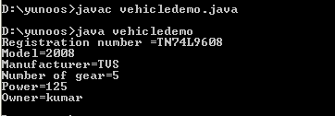

**Result** :Thus the above java program was executed and verified successfully.

EX:No:9 Write a program to create a own exception subclass that throws exception if the given number is not in the range of numbers.

**AIM:**

To create a own exception subclass that throws exception if the given number is not in the range of number.

**ALGORITHM**:

Step1: Start the program

Step2: Create the class outrange

Step3: Give the instant variable declaration for the class and the subclass.

Step4: Get the method for that class and get the related function.

Step5: Execute and terminate the program.

import java.io.*;

class RangeException extends Exception

{

RangeException(String e)

{

super(e);

}

}

public class outrange

{

public static void main(String args[])

{

int a=0,b=700,n;

try

{

DataInputStream din=new DataInputStream(System.in);

System.out.println("Enter any number:");

n=Integer.parseInt(din.readLine());

if(n<a || n >b)throw new RangeException("Number out of range");

System.out.println("The given number"+n+"is in the range of number"+a+"and"+b);

}

catch(RangeException s)

{

System.out.println(s);

}

catch(IOException e)

{

System.out.println(e);

}

}

}

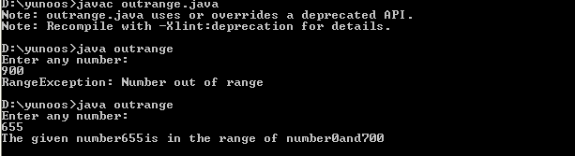

**Result** :Thus the above java program was executed and verified successfully.

Ex:NO : 10 Write a Program to create three threads first thread displays “Good Morning” everyone second, the second thread displays “Hello” ever4y two seconds and the third thread displays “Welcome” every three seconds.

**AIM:**

To create a thread program to create three threads, first thread displays “good morning” everyone second the second thread displays “Hello” every two second and the third thread displays “welcome” every three seconds.

**ALGORITHM**:

Step1: Start the program

Step2: Create the class threaddemo

Step3: Give the instant variable declaration for the class and the subclass.

Step4: Get the method for that class and get the related function.

Step5: Execute and terminate the program.

class one extends Thread

{

public void run()

{

try

{

sleep(1000);

System.out.println("Good Morning");

}

catch(Exception e)

{

System.out.println(e);

}

}

}

class two extends Thread

{

public void run()

{

try

{

sleep(2000);

System.out.println("Hello");

}

catch(Exception e)

{

System.out.println(e);

}

}

}

class three extends Thread

{

public void run()

{

try

{

sleep(3000);

System.out.println("Welcome");

}

catch(Exception e)

{

System.out.println(e);

}

}

}

class threaddemo

{

public static void main(String args[])

{

one a=new one();

two b=new two();

three c=new three();

a.start();

b.start();

c.start();

}

}

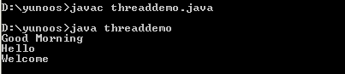

**Result** :Thus the above java program was executed and verified successfully.

Ex:N0:11 Write a program to create a file using Byte Stream or character stream class.

**AIM:**

To create a file using Byte stream or character stream class.

**ALGORITHM**:

Step1: Start the program

Step2: Create the class filedemo

Step3: Give the instant variable declaration for the class and the subclass.

Step4: Get the method for that class and get the related function.

Step5: Execute and terminate the program.

import java.io.*;

class filedemo

{

public static void main(String args[])

{

try

{

DataInputStream din=new DataInputStream(System.in);

System.out.println("Enter the data to write:");

String s=din.readLine();

FileOutputStream fout=new FileOutputStream("demo.txt");

byte b[]=s.getBytes();

fout.write(b);

System.out.println("File created successfully");

fout.close();

}

catch(IOException e)

{

System.out.println(e);

}

}

}

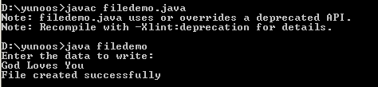

**Result** :Thus the above java program was executed and verified successfully.

**EXERCISE 12 Write a program to demonstrate Mouse Events.**

**AIM:**

To demonstrate mouse events.

**ALGORITHM**:

Step1: Start the program

Step2: Create the class Mouse Motion Demo using applet

Step3: Give the instant variable declaration for the class and its applet methods.

Step4: Get the method for that class and get the related mouse events.

Step5: Execute and terminate the program.

**PROGRAM:**

/*<applet code="mousemotiondemo"width=300 height=200></applet>*/

import java.awt.*;

import java.applet.*;

import java.awt.event.*;

public class mousemotiondemo extends Applet

{

String msg="";

public void init()

{

addMouseListener(new MouseManager());

addMouseMotionListener(new MouseMotioner());

}

public void paint(Graphics g)

{

Font f1=new Font("Ariel",Font.BOLD,20);

g.setFont(f1);

g.drawString(msg,100,50);

}

class MouseManager implements MouseListener

{

public void mousePressed(MouseEvent e)

{

msg="Mouse Pressed";

repaint();

}

public void mouseReleased(MouseEvent e)

{

msg="Mouse Released";

repaint();

}

public void mouseClicked(MouseEvent e)

{

msg="Mouse Clicked";

repaint();

}

public void mouseEntered(MouseEvent e)

{

msg="Mouse Entered";

repaint();

}

public void mouseExited(MouseEvent e)

{

msg="Mouse Exited";

repaint();

}

}

class MouseMotioner implements MouseMotionListener

{

public void mouseMoved(MouseEvent e)

{

msg="Mouse moved";

repaint();

}

public void mouseDragged(MouseEvent e)

{

msg="Mouse Dragged";

repaint();

}

}

}

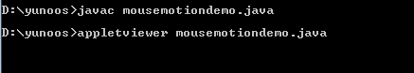

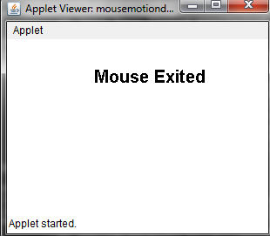

**Result** :Thus the above java applet program was executed and verified successfully.

**EXERCISE 13**

**AIM:**

To display basic shapes using Graphics class and fill them using color class.

**ALGORITHM**:

Step1: Start the program

Step2: Create the class shapes using applet

Step3: Give the instant variable declaration for the class and its applet methods.

Step4: Get the graphics method for that class and get the related functions.

Step5: Execute and terminate the program.

**PROGRAM:**

//<applet code="shapes" width=500 height=300></applet>

import java.io.*;

import java.awt.*;

import java.applet.*;

public class shapes extends Applet

{

Color c1=new Color(255,0,0);

Color c2=new Color(0,255,0);

Color c3=new Color(0,0,255);

public void paint(Graphics g)

{

g.setColor(c1);

g.fillRect(10,10,70,40);

g.setColor(c2);

g.fillOval(100,40,10,10);

g.setColor(c3);

g.fillArc(200,30,50,30,100,180);

}

}

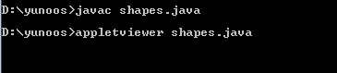

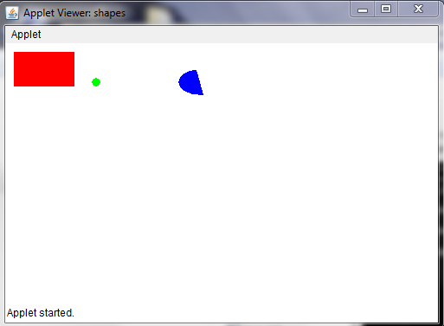

**Result** :Thus the above java applet program was executed and verified successfully.

**EXERCISE 14**

**AIM:**

To create a simple calculator to perform addition, subtraction, multiplication and division using button, label and text field.

**ALGORITHM**:

Step1: Start the program

Step2: Create the class calculator using Japplet

Step3: Give the instant variable declaration for the class and its Japplet methods.

Step4: Get the calculator panel sub classes and its methods for that class and get the related functions.

Step5: Execute and terminate the program.

**PROGRAM:**

import javax.swing.*;

import javax.swing.JOptionPane;

import java.awt.*;

import java.awt.event.*;

//<applet code=calculator height=300 width=200></applet>

public class calculator extends JApplet{

public void init() {

CalculatorPanel calc=new CalculatorPanel();

getContentPane().add(calc);

}

}

class CalculatorPanel extends JPanel implements ActionListener

{

JButton

n1,n2,n3,n4,n5,n6,n7,n8,n9,n0,plus,minus,mul,div,dot,equal;

static JTextField result=new JTextField("0",45);

static String lastCommand=null;

JOptionPane P=new JOptionPane();

double preRes=0,secVal=0,res;

private static void assign(String no)

{

if((result.getText()).equals("0")) result.setText(no);

else if(lastCommand=="=")

{

result.setText(no);

lastCommand=null;

}

else

result.setText(result.getText()+no);

}

public CalculatorPanel() {

setLayout(new BorderLayout());

result.setEditable(false);

result.setSize(300,200);

add(result,BorderLayout.NORTH);

JPanel panel=new JPanel();

panel.setLayout(new GridLayout(4,4));

n7=new JButton("7");

panel.add(n7);

n7.addActionListener(this);

n8=new JButton("8");

panel.add(n8);

n8.addActionListener(this);

n9=new JButton("9");

panel.add(n9);

n9.addActionListener(this);

div=new JButton("/");

panel.add(div);

div.addActionListener(this);

n4=new JButton("4");

panel.add(n4);

n4.addActionListener(this);

n5=new JButton("5");

panel.add(n5);

n5.addActionListener(this);

n6=new JButton("6");

panel.add(n6);

n6.addActionListener(this);

mul=new JButton("*");

panel.add(mul);

mul.addActionListener(this);

n1=new JButton("1");

panel.add(n1);

n1.addActionListener(this);

n2=new JButton("2");

panel.add(n2);

n2.addActionListener(this);

n3=new JButton("3");

panel.add(n3);

n3.addActionListener(this);

minus=new JButton("-");

panel.add(minus);

minus.addActionListener(this);

dot=new JButton(".");

panel.add(dot);

dot.addActionListener(this);

n0=new JButton("0");

panel.add(n0);

n0.addActionListener(this);

equal=new JButton("=");

panel.add(equal);

equal.addActionListener(this);

plus=new JButton("+");

panel.add(plus);

plus.addActionListener(this);

add(panel,BorderLayout.CENTER);

}

public void actionPerformed(ActionEvent ae)

{

if(ae.getSource()==n1)assign("1");

else if(ae.getSource()==n2)assign("2");

else if(ae.getSource()==n3)assign("3");

else if(ae.getSource()==n4)assign("4");

else if(ae.getSource()==n5)assign("5");

else if(ae.getSource()==n6)assign("6");

else if(ae.getSource()==n7)assign("7");

else if(ae.getSource()==n8)assign("8");

else if(ae.getSource()==n9)assign("9");

else if(ae.getSource()==n0)assign("0");

else if(ae.getSource()==dot)

{

if(((result.getText()).indexOf("."))==-1)

result.setText(result.getText()+".");

}

else if(ae.getSource()==minus)

{

preRes=Double.parseDouble(result.getText());

lastCommand="-";

result.setText("0");

}

else if(ae.getSource()==div)

{

preRes=Double.parseDouble(result.getText());

lastCommand="/";

result.setText("0");

}

else if(ae.getSource()==equal)

{

secVal=Double.parseDouble(result.getText());

if(lastCommand.equals("/"))

res=preRes/secVal;

else if(lastCommand.equals("*"))

res=preRes*secVal;

else if(lastCommand.equals("_"))

res=preRes-secVal;

else if(lastCommand.equals("+"))

res=preRes+secVal;

result.setText(""+res);

lastCommand="=";

}

else if(ae.getSource()==mul)

{

preRes=Double.parseDouble(result.getText());

lastCommand="*";

result.setText("0");

}

else if(ae.getSource()==plus)

{

preRes=Double.parseDouble(result.getText());

lastCommand="+";

result.setText("0");

}

}

}



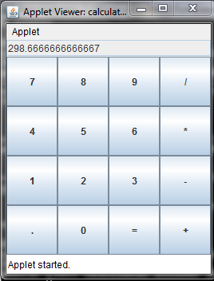

**Result** :Thus the above java applet program was executed and verified successfully.